Take Your Child to

Work Experience

Diary

Name of Pupil:

Year Group:

House:

Key Points to Remember

* Fill in the relevant sections BEFORE you go on work experience.
* Complete the daily diary DURING your work experience (Daily Log).
* ENJOY YOUR WORK EXPERIENCE AND MAKE THE MOST OF IT!

Welcome to Work Experience

Dear Pupil,

Work experience is important because:

• Employers are always eager to see how young people get on in the workplace environment. This is your chance to show that you have the key skills, right attitude and the right personal qualities that show you are work-ready.

• You have the chance to try out a career option or to simply see what the working world is like!

• You have the chance to look behind the scenes and see how the business fits into the business life of Warwickshire, the West Midlands and perhaps beyond.

• This is one of the first steps to a fulfilling and rewarding career – wherever you go and whatever you do!

Make the most of your work experience placement.

Practical things to know

Ensure you know the dates and times of your placement

Check your internet connections before hand

Make sure you have told the school the dates and times of your placement

**If you are ill or unable to work for any reason, contact the placement AND College before 9.00am.**

**If you have any concerns, contact College immediately.**

College telephone number 024 76 757300

Person to contact Reception- Etone College

Work Experience Preparation Sheet

Company Name ___________________________________________________________________

Address _________________________________________________________________________

Contact Name ____________________________________________________________________

Telephone Number_________________________________________________________________

Department (if applicable) ____________________________________________________________

# 

# Health and safety questionsN:\Downloads\Etone L4L Logo.png

Is there a Company health and safety policy?

What training opportunities exist for employees:

Ask your employer for interview tips:

What training and qualifications will you need in order to follow this career path?

Does client confidentiality apply to your role – if so how?

During your placement can you research consumer rights and list them below?

If you were to be employed in this industry what could you expect your starting salary to be?

­­­­­­­­­­­­­­­­­­­­What is the Equality Act 2010 and how does it apply to the job role you are currently in?

Pupil’s Daily Log – Link this to the employability skills you have used

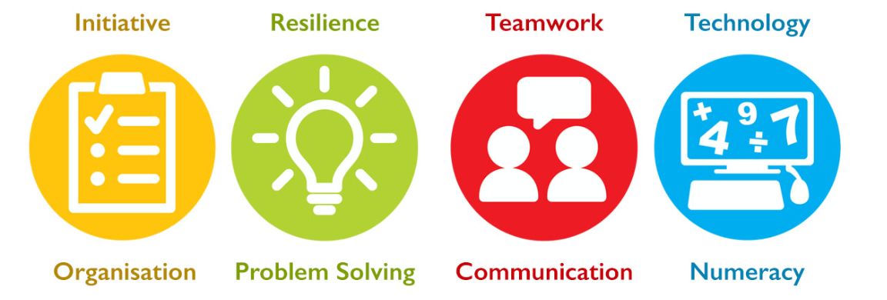

|  |  |
| --- | --- |
| **Days** | **Tasks completed and skills used** |
| April 3rd |  |

