Work Experience Diary
Monday 17th July – Friday 21st July
2023
Name of Pupil :_____________________________________

Key Points to Remember
- Fill in the relevant sections BEFORE you go on work experience.
- Complete the daily diary DURING your work experience (Daily Log).
- If you are ill or unable to attend during work experience, you MUST contact the placement AND college before 9.00am.
Etone College telephone number: 02476 757300.
- Complete your evaluation IMMEDIATELY after your work experience has finished.
- Write to the placement thanking them for giving you work experience.
- ENJOY YOUR WORK EXPERIENCE AND MAKE THE MOST OF IT!

Welcome to Work Experience
Dear Pupil,
Work experience is important because:
• Employers are always eager to see how young people get on in the workplace environment. This is your chance to show that you have the key skills, right attitude and the right personal qualities that show you are work-ready.
• You have the chance to try out a career option or to simply see what the working world is like!
• You have the chance to look behind the scenes and see how the business fits into the business life of Warwickshire, the West Midlands and perhaps beyond.
• This is one of the first steps to a fulfilling and rewarding career – wherever you go and whatever you do!
Make the most of your work experience placement.

Practical things to know
Where to go:
• Before your first day make sure you know how to get to the location that you’ll be working at.
• Work out the best way to get there and back home and how long the journey time will be.
• Make sure that you discuss these arrangements with your parent/carer.
• This way you will arrive on time, relaxed and ready for the day.
Work times:
• Your work experience day will be by arrangement. It should be approximately 8 hours with 1 hour for lunch.
Mobile phones:
• Check with placement about the use of mobile phones.
• If your parent/carer or College need to contact you, they can reach you through the work experience co-ordinator. Ensure that you give the name of this person to your parent/carer.
Behaviour at work:
• The way you behave at work is really important – you will be representing your College as well as your company.
• You should always be helpful and polite.
• Don’t be scared to show that you don’t know something. Smile, apologise and explain you are on work experience. Then find an employee who can help.

If you are ill or unable to work for any reason, contact the placement AND College before 9.00am.
If you have any concerns, contact College immediately.

College telephone number 02476 757300
Person to contact Miss Moore or your Head of House - Etone College

Work Experience Preparation Sheet
Company Name ___________________________________________________________________
Address _________________________________________________________________________
Contact Name ____________________________________________________________________
Telephone Number_________________________________________________________________
Department (if applicable) ____________________________________________________________
Where do I report to on my first day? ___________________________________________________
Start time ________________________________ Finish time _______________________________
Lunch break ______________________________________________________________________
Lunch arrangements _________________________________________________________________
Dress (smart etc.) __________________________________________________________________

Health and safety questions

What is the fire and evacuation procedure?________________________________________________
Where do you go for first aid?__________________________________________________________
Which equipment are you not allowed to handle?____________________________________________
Is there a Company safety policy?_____
Which areas, if any, are off limits?_________________________
What advice have you been given about how to lift and handle materials and equipment correctly?
________________________________________________________________________________
Are work areas kept clear in case of emergency?
________________________________________________________________________________
Will you be exposed to any risks and have you been told how to avoid them?_______________________

Do you have to use any protective and safety equipment? ________________________________________________________________________________
Who do you report accidents to? ________________________________________________________________________________
Where are the toilets and are there any special hygiene requirements? _______________________________________________________________________________
What training opportunities exist for employees:

Ask your employer for interview tips:

What training and qualifications will you need in order to follow this career path?

Does client confidentiality apply to your role – if so how?

During your placement can you research consumer rights and list them below?

If you were to be employed in this industry what could you expect your starting salary to be?

Can you write a list of expenses again your possible income and budget for a week – include travel /food accommodation/rent/pleasure/lunch money/clothing?

What is the Equality Act 2010 and how does it apply to the job role you are currently in?

Pupil’s Daily Log – Link this to the employability skills you have used
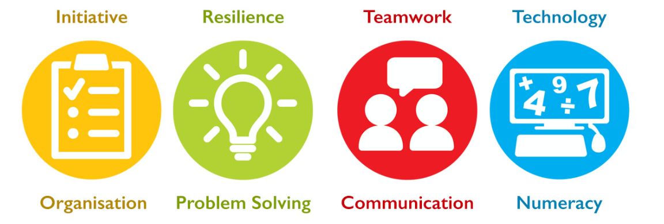

Days | Tasks completed and skills used
Monday
Tuesday
Wednesday
Thursday

Friday

Supervisor’s Daily Log
Day | Punctual | Presentable | Polite | Other comments
Monday | Y / N | Y / N | Y / N
Tuesday | Y / N | Y / N | Y / N
Wednesday | Y / N | Y / N | Y / N
Thursday | Y / N | Y / N | Y / N
Friday | Y / N | Y / N | Y / N
